# Hands-on Lab 1: Introduction to Excel for the web

Estimated time needed: 20 minutes

Microsoft Excel is the most widely used spreadsheet software even three decades after its initial release. For all these years it has been available as a standard application that needed to be installed on your desktop; but it is not just a desktop app anymore. Now, you can even use Excel when you're online by using 'Excel for the web' - and run it right in your web browser without installing anything on your desktop!

'Excel for the web' (sometimes referred to as Excel Online) can be used at no charge as part of a free Microsoft account. Although it does not have all of the capabilities of the desktop and paid online versions, the free web version provides many of the key features.

# Software Used in this Lab

The instruction videos in this course use the full Excel Desktop version as this has all the available product features, but for the hands-on labs we will be using the free 'Excel for the web' version as this is available to everyone.

Although you can use the Excel Desktop software if you have access to this version, it is recommended that you use Excel for the web for the hands-on labs as the lab instructions specifically refer to this version, and there are some small differences in the interface and available features.

# Dataset Used in this Lab

The dataset used in this lab comes from the following source: [https://www.kaggle.com/sudalairajkumar/indian-startup-funding](https://www.kaggle.com/sudalairajkumar/indian-startup-funding?cm_mmc=Email_Newsletter-_-Developer_Ed%2BTech-_-WW_WW-_-SkillsNetwork-Courses-IBMDeveloperSkillsNetwork-DA0130EN-SkillsNetwork-20531059&cm_mmca1=000026UJ&cm_mmca2=10006555&cm_mmca3=M12345678&cvosrc=email.Newsletter.M12345678&cvo_campaign=000026UJ&cm_mmc=Email_Newsletter-_-Developer_Ed%2BTech-_-WW_WW-_-SkillsNetwork-Courses-IBMDeveloperSkillsNetwork-DA0130EN-SkillsNetwork-20531059&cm_mmca1=000026UJ&cm_mmca2=10006555&cm_mmca3=M12345678&cvosrc=email.Newsletter.M12345678&cvo_campaign=000026UJ) under a [CC0: Public Domain license](https://creativecommons.org/publicdomain/zero/1.0?cm_mmc=Email_Newsletter-_-Developer_Ed%2BTech-_-WW_WW-_-SkillsNetwork-Courses-IBMDeveloperSkillsNetwork-DA0130EN-SkillsNetwork-20531059&cm_mmca1=000026UJ&cm_mmca2=10006555&cm_mmca3=M12345678&cvosrc=email.Newsletter.M12345678&cvo_campaign=000026UJ). Acknowledgement and thanks also goes to [https://trak.in](https://trak.in/?cm_mmc=Email_Newsletter-_-Developer_Ed%2BTech-_-WW_WW-_-SkillsNetwork-Courses-IBMDeveloperSkillsNetwork-DA0130EN-SkillsNetwork-20531059&cm_mmca1=000026UJ&cm_mmca2=10006555&cm_mmca3=M12345678&cvosrc=email.Newsletter.M12345678&cvo_campaign=000026UJ&cm_mmc=Email_Newsletter-_-Developer_Ed%2BTech-_-WW_WW-_-SkillsNetwork-Courses-IBMDeveloperSkillsNetwork-DA0130EN-SkillsNetwork-20531059&cm_mmca1=000026UJ&cm_mmca2=10006555&cm_mmca3=M12345678&cvosrc=email.Newsletter.M12345678&cvo_campaign=000026UJ&cm_mmc=Email_Newsletter-_-Developer_Ed%2BTech-_-WW_WW-_-SkillsNetwork-Courses-IBMDeveloperSkillsNetwork-DA0130EN-SkillsNetwork-20531059&cm_mmca1=000026UJ&cm_mmca2=10006555&cm_mmca3=M12345678&cvosrc=email.Newsletter.M12345678&cvo_campaign=000026UJ) who were generous enough to share the data publicly for free.

We are using a modified subset of that dataset for the lab, so to follow the lab instructions successfully please use the dataset provided with the lab, rather than the dataset from the original source.

# Objectives

After completing this lab, you will be able to:

* Sign up for a Microsoft Account to use Excel for the web
* Sign in, upload and open a workbook in Excel for the web

# Exercise 1: Sign-up for a Microsoft Account to Use Excel for the web

In this exercise, you will sign up for a Microsoft Account to use Excel for the web.

* If you already have a Microsoft account, you can skip Exercise 1 and proceed to Exercise 2 directly.

1. Go to [www.office.com](https://www.office.com/?cm_mmc=Email_Newsletter-_-Developer_Ed%2BTech-_-WW_WW-_-SkillsNetwork-Courses-IBMDeveloperSkillsNetwork-DA0130EN-SkillsNetwork-20531059-www-coursera-org-www-coursera-org&cm_mmca1=000026UJ&cm_mmca2=10006555&cm_mmca3=M12345678&cvosrc=email.Newsletter.M12345678&cvo_campaign=000026UJ). Click Sign in  
   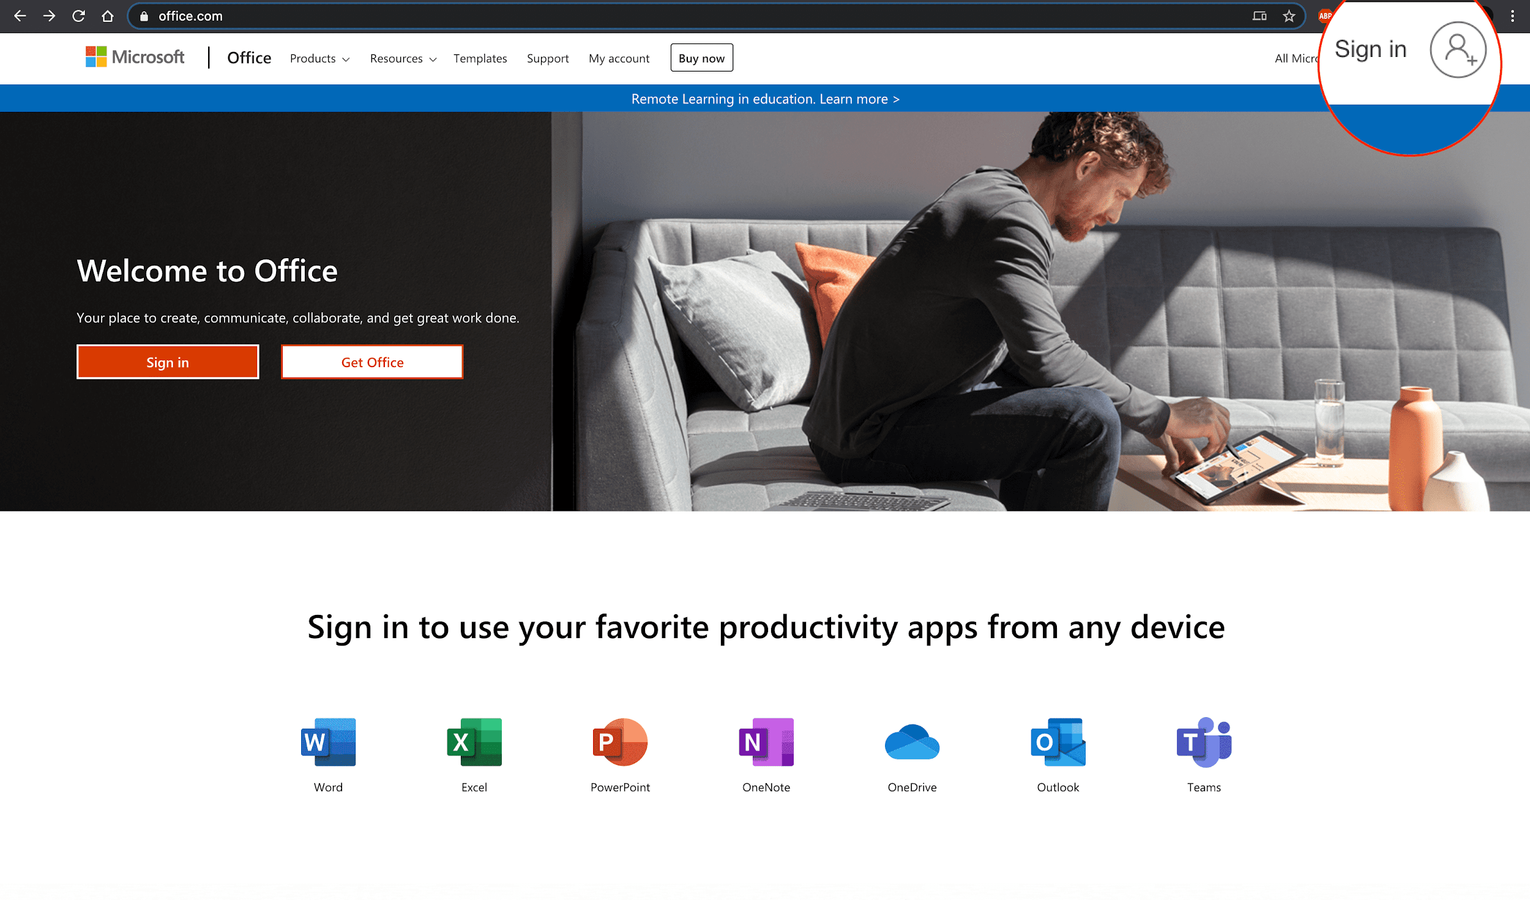
2. Click Create one!  
   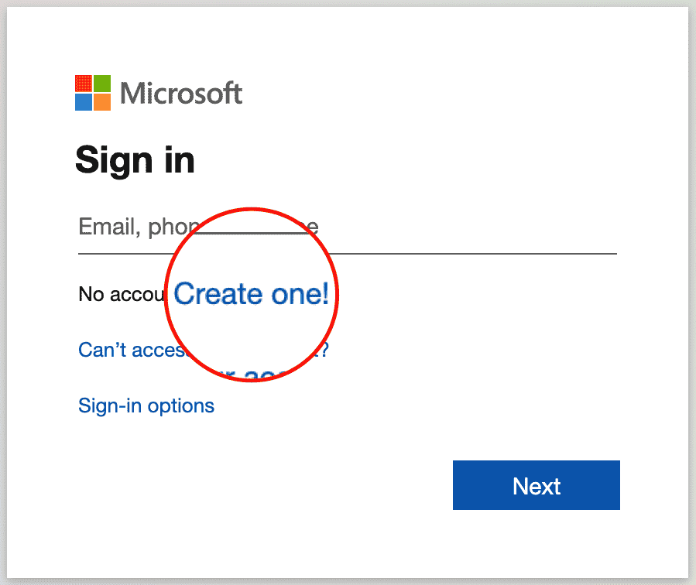
3. Enter your existing email id with which you want to create a Microsoft account. Click Next.  
   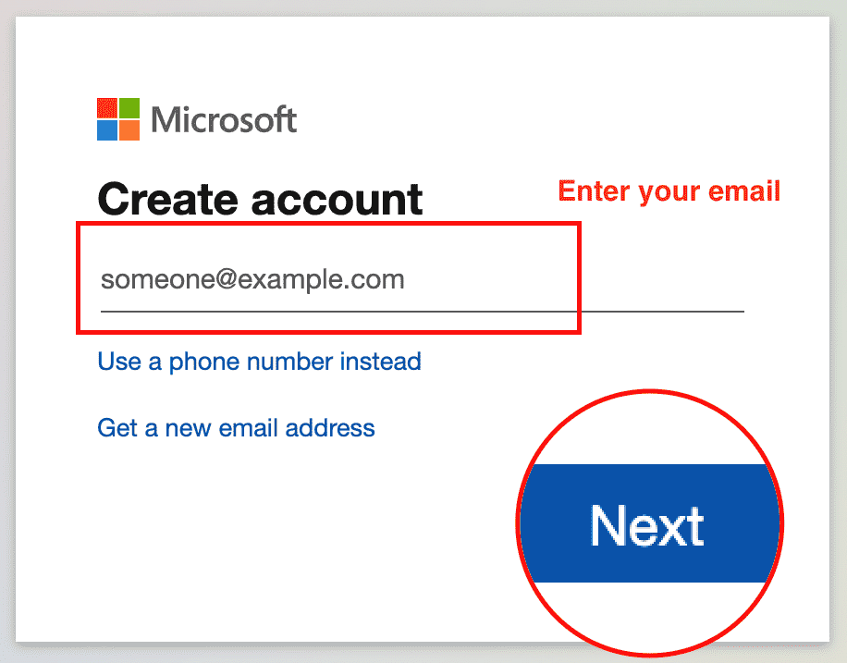
4. Enter your password and click Next.  
   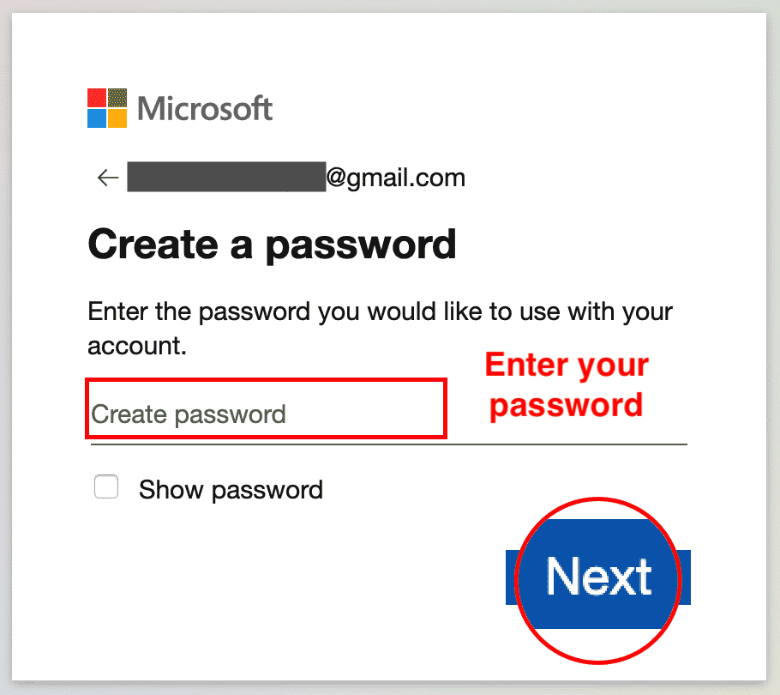
5. Enter the code you received by email. Click Next.  
   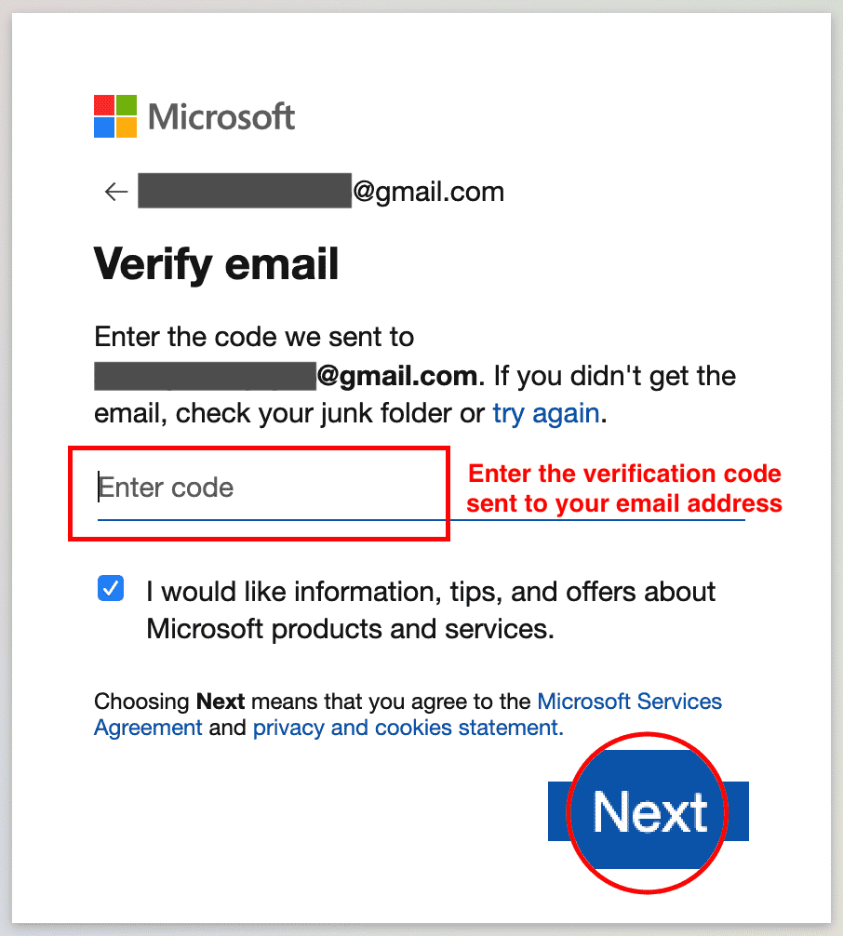
6. Enter your phone number and click Send Code.  
   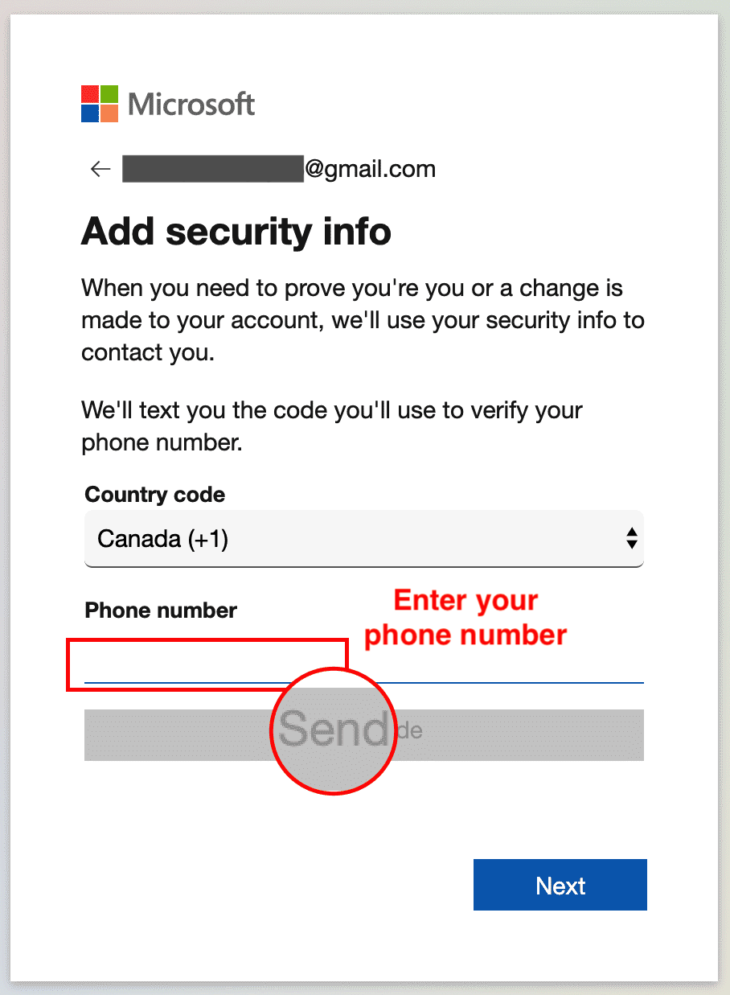
7. Enter the access code you received as a text on your phone, then click Next.  
   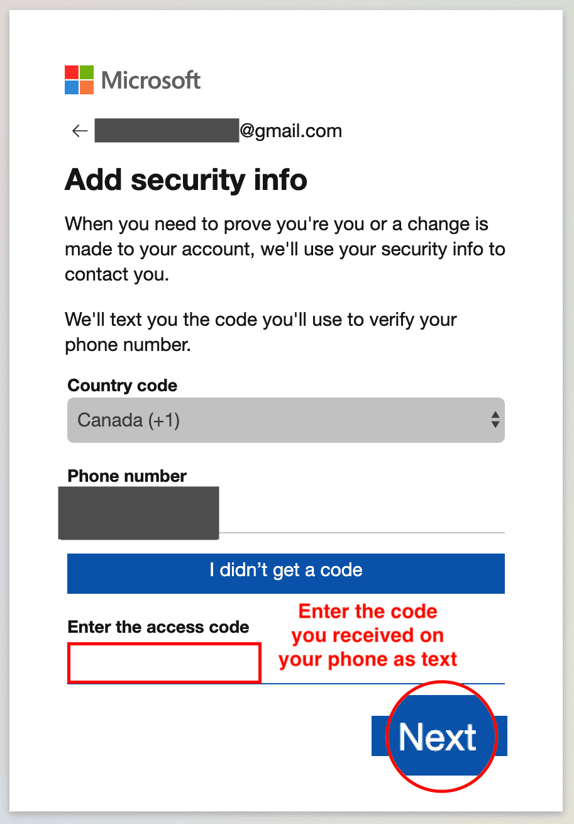
8. You are now done with the sign up procedure. Now since you are signed in after sign up at this stage, you can proceed directly to Task B of Exercise 2.  
   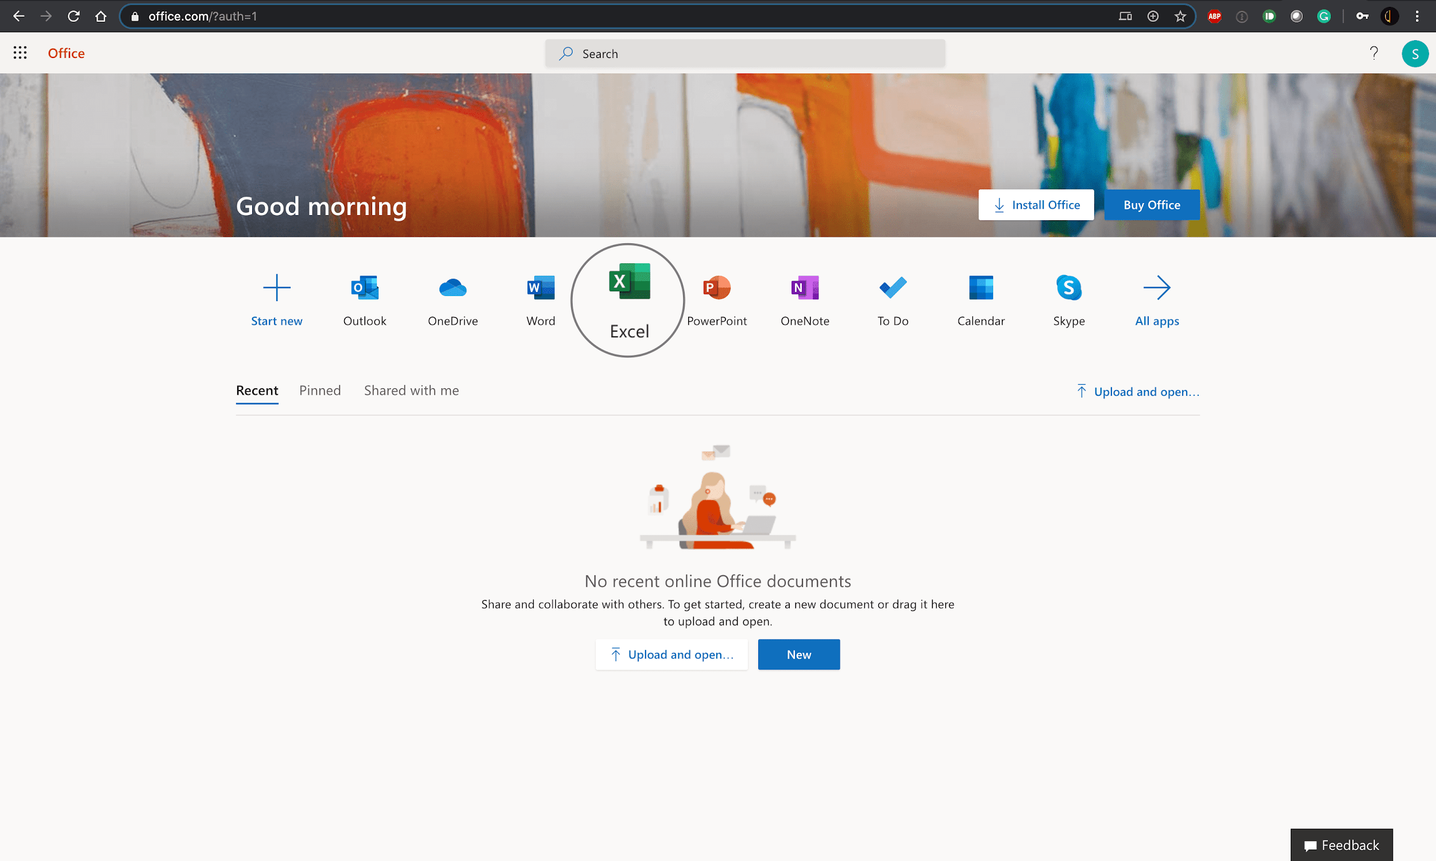

# Exercise 2: Sign-in, Upload and Open a Workbook in Excel for the web

In this exercise, you will sign in to Excel for the web, open a new workbook and then upload and open a workbook.

## Task A: Sign in to Excel for the web

1. Go to [www.office.com](https://www.office.com/?cm_mmc=Email_Newsletter-_-Developer_Ed%2BTech-_-WW_WW-_-SkillsNetwork-Courses-IBMDeveloperSkillsNetwork-DA0130EN-SkillsNetwork-20531059&cm_mmca1=000026UJ&cm_mmca2=10006555&cm_mmca3=M12345678&cvosrc=email.Newsletter.M12345678&cvo_campaign=000026UJ). Click Sign in.  
   
2. Enter your sign in email.  
   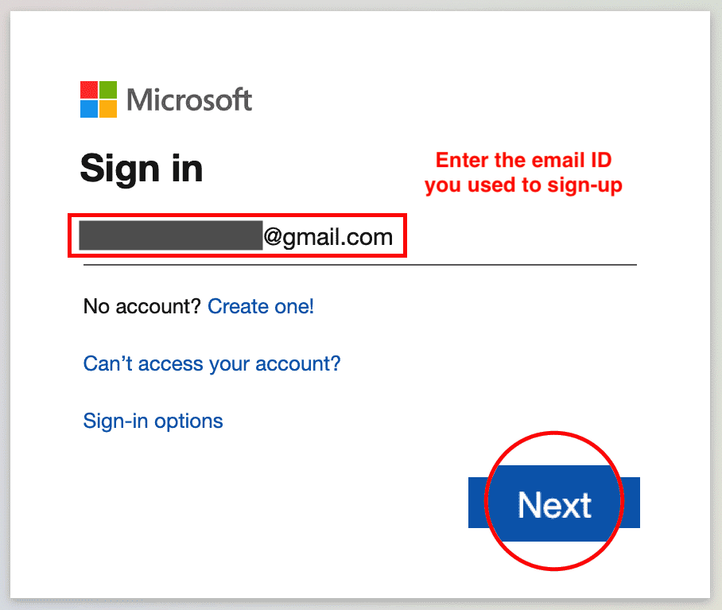
3. Enter your password.  
   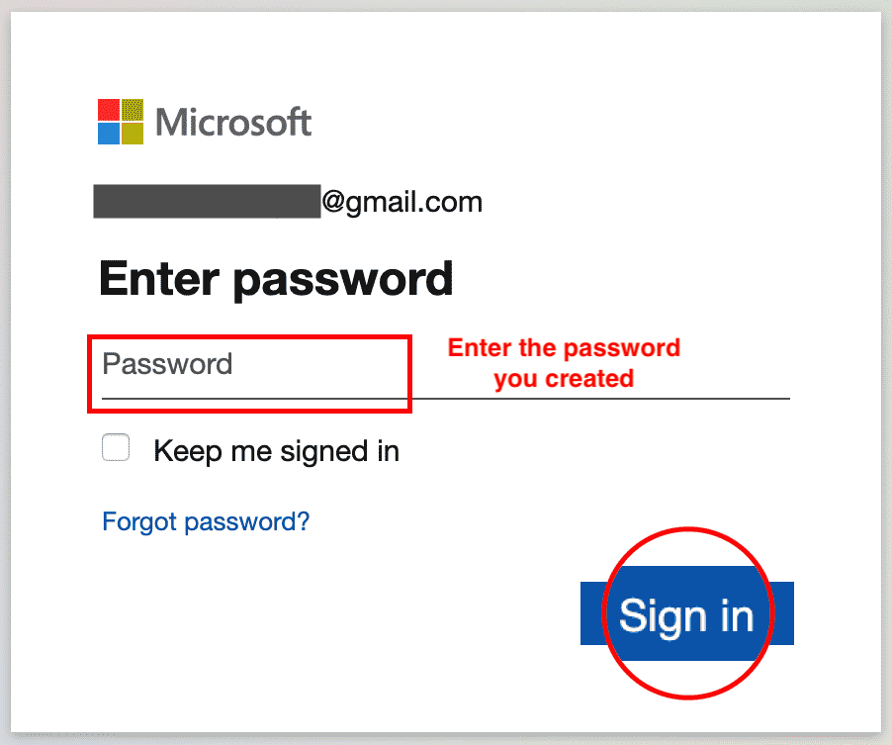
4. You are now signed in.  
   

## Task B: Open a new workbook in Excel for the web

1. Click on the Excel icon.  
   
2. Click New blank workbook.  
   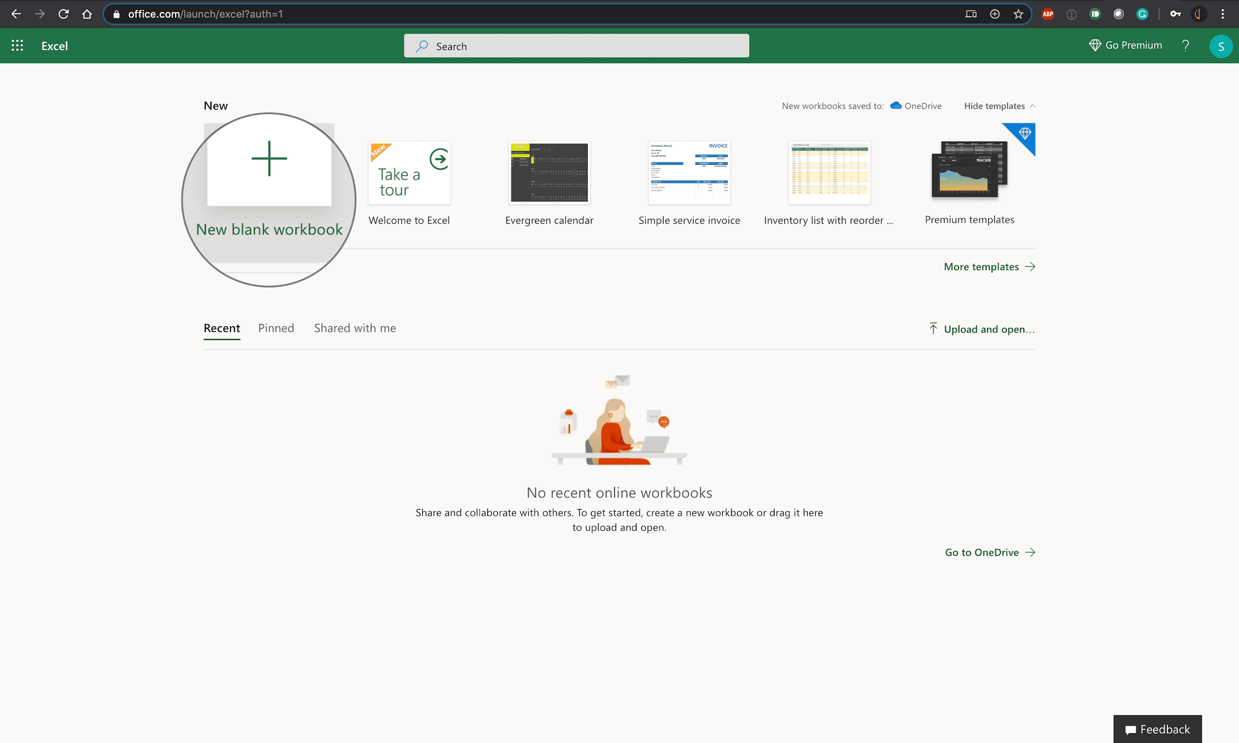
3. You have successfully opened a new workbook in Excel for the web.  
   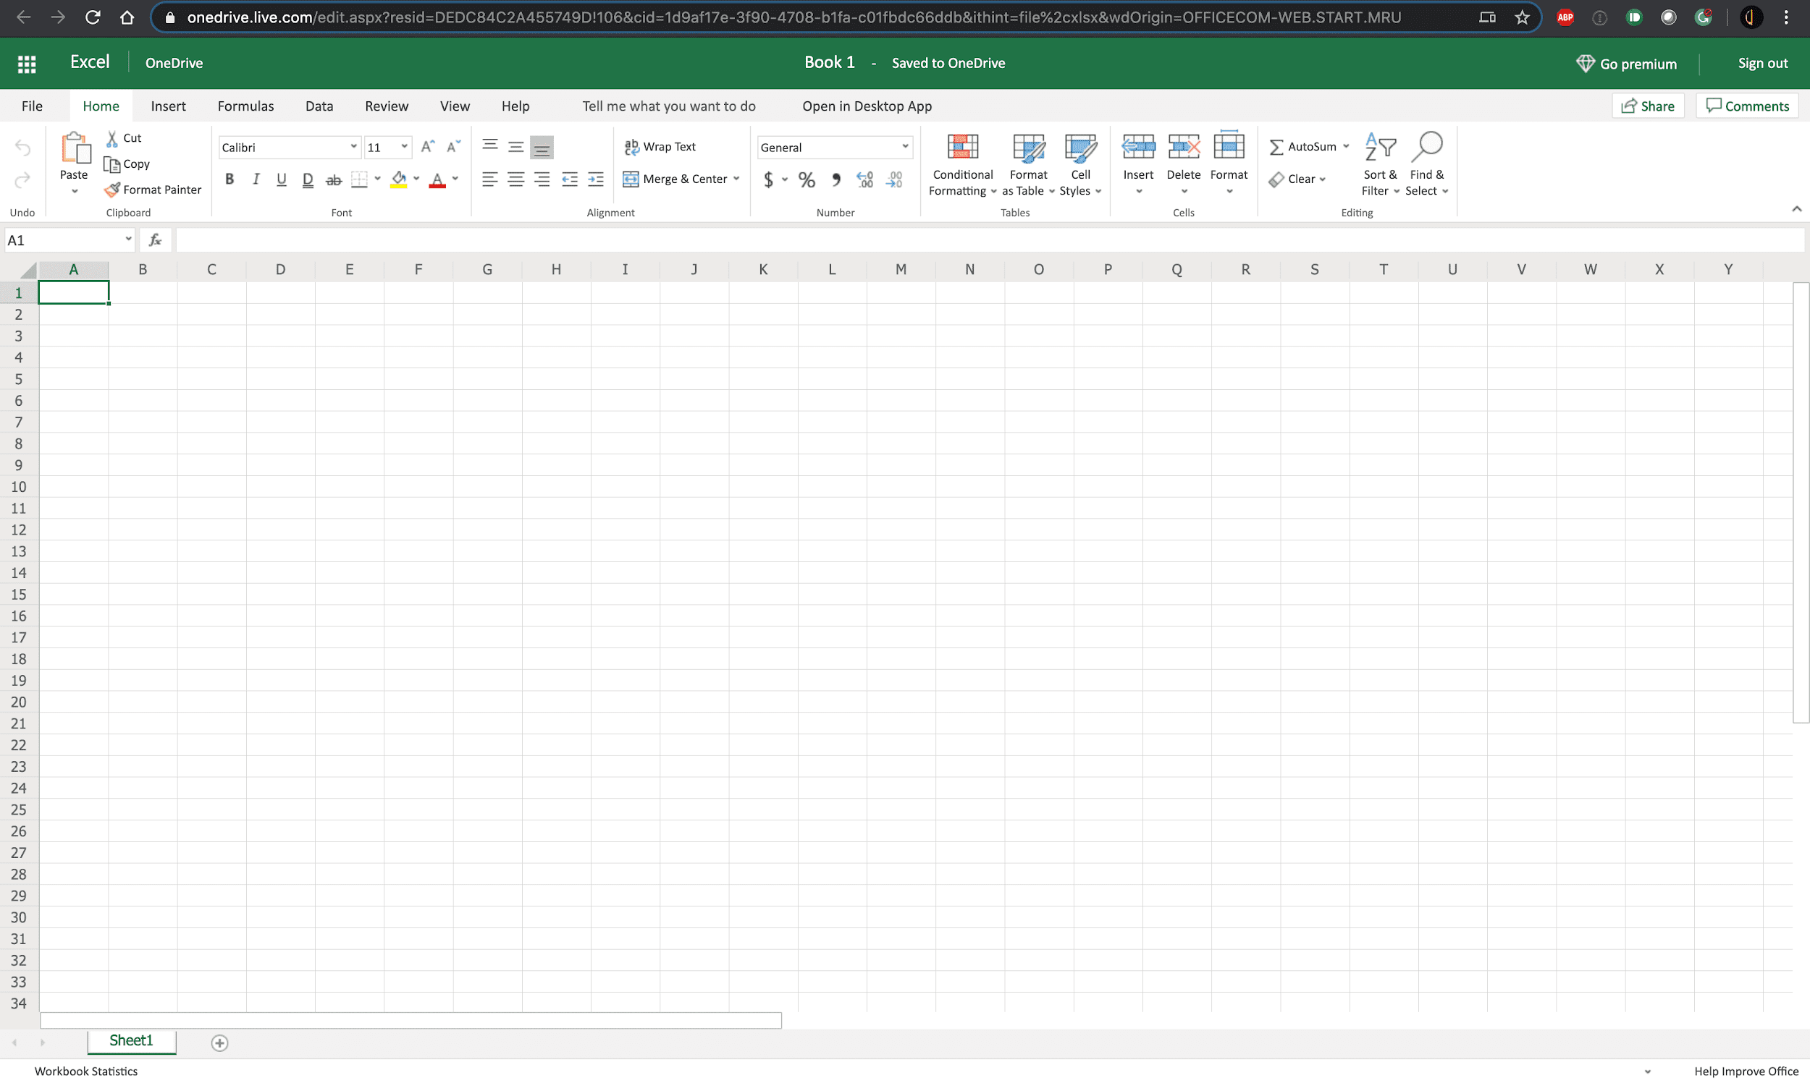

## Task C: Upload and Open a workbook in Excel for the web

1. Download the file [indian_startup_funding_Lab1.xlsx](https://cf-courses-data.s3.us.cloud-object-storage.appdomain.cloud/IBMDeveloperSkillsNetwork-DA0130EN-SkillsNetwork/Hands-on%20Labs/Lab%201%20-%20Access%20to%20the%20environment%20-%20Excel%20for%20the%20web/indian_startup_funding_Lab1.xlsx).
2. To upload and open a workbook in Excel for the web, click the App Launcher (cube of dots) in the top left corner. Click Excel icon. Then click Upload and open... and select the indian_startup_funding_Lab1.xlsx file.  
   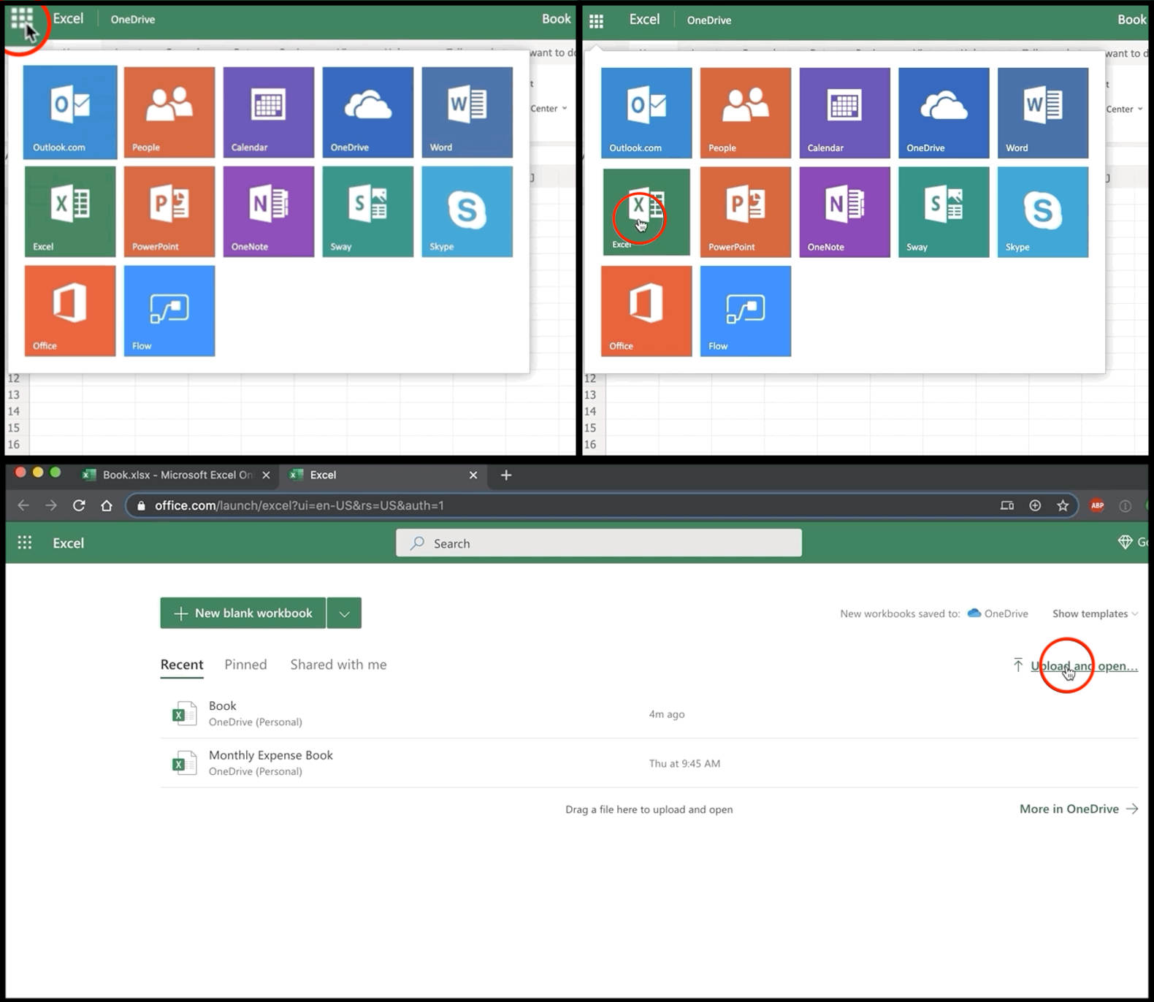
3. The file will be uploaded to your OneDrive of the Microsoft Account you signed up and used to open Excel for the web.  
   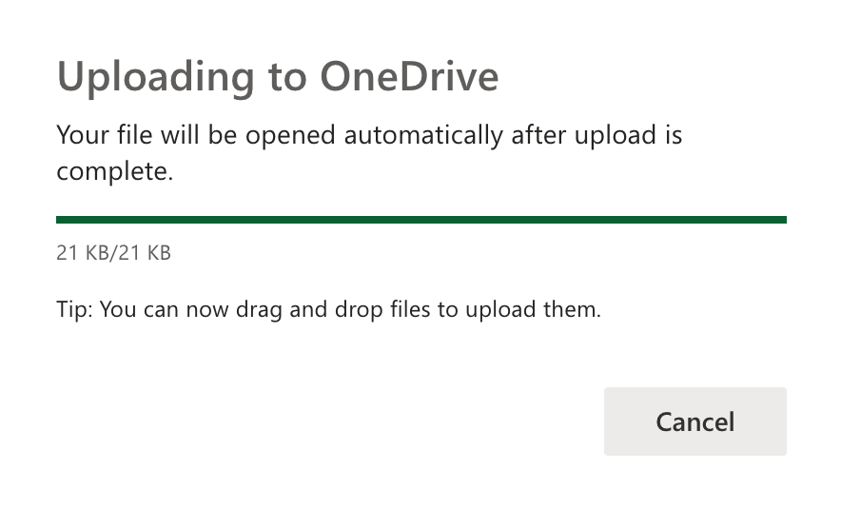
4. You have successfully uploaded and opened a workbook in Excel for the web.  
   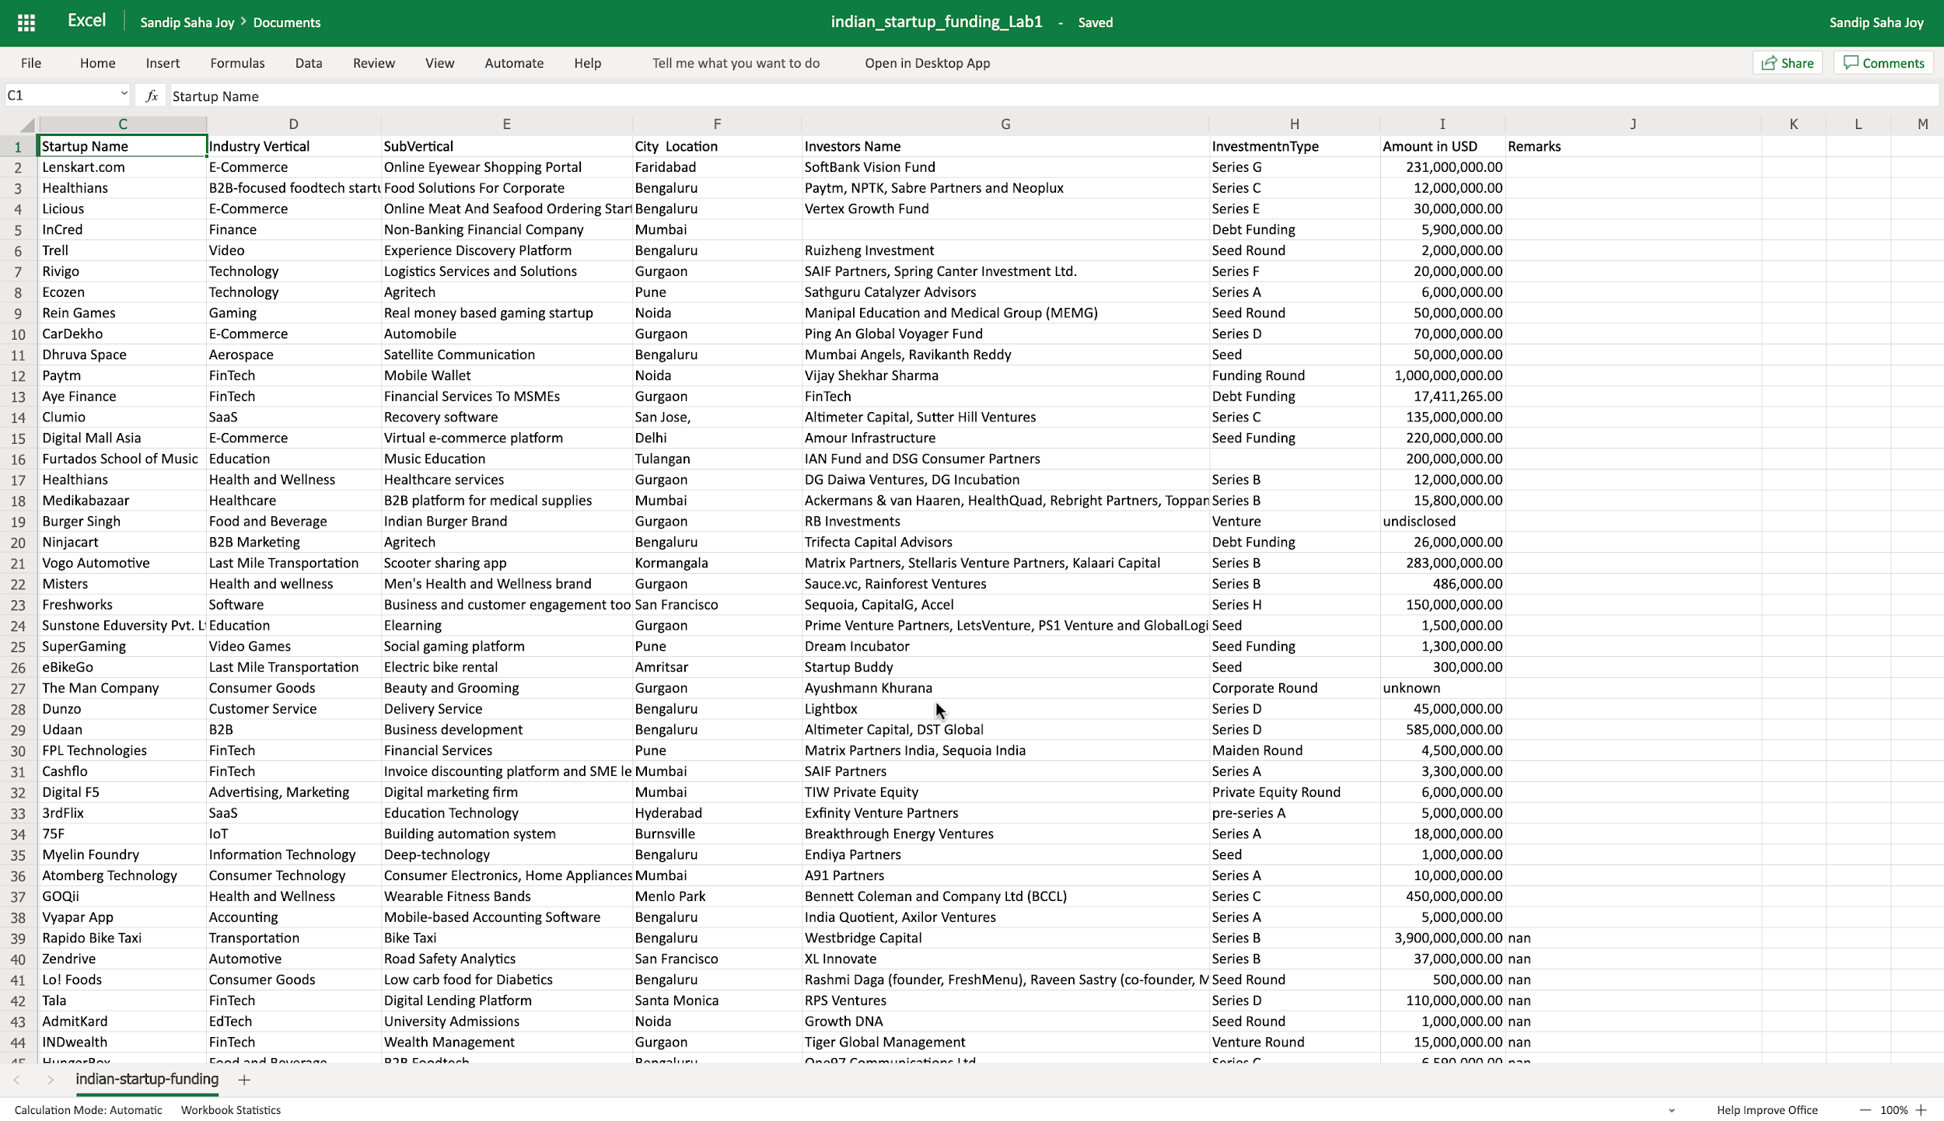

### Congratulations! You have completed Lab 1, and you are ready for the next topic.